APR Ready To Roll Promotion & Communications Package
OVERVIEW: This package includes sample turnkey promotions and candidate communications that will take you from START (promoting your program and orientation) to FINISH (congratulatory messages for APR achievement).

NEWSLETTER BLURB ANNOUNCING APR READY TO ROLL PROGRAM ORIENTATION
New Year, New APR?
APR Ready to Roll Overview and Luncheon (INSERT DATE)
You started (INSERT YEAR) with major life, career and professional development goals -- or maybe just one? If one of those goals happens to be earning your Accreditation in Public Relations (APR) your time is near and sooner than you thought. PRSA _________Chapter is hosting an APR Ready to Roll Overview & Lunch Orientation this (insert date, time, location).
Still time to board the APR train?
Absolutely! Just complete this survey (create 4-5 question survey and link here) and to help us shape workshops, study sessions, and other offerings. Then, (insert APR chair(s) names and emails) will contact you with more details, but please email us today if you have any immediate questions!
Earn Your APR, the Gold Standard in Public Relations
You're APR Ready to Roll. You know it. You feel it. You can do it. But don't take our word for it, PRSA Nashville Chapter Secretary Jared Porter, APR, a graduate of our 2024 APR cohort, has this to say... (follow this with your own quote or -- once you have your first cohort and new APRs, insert their testimonial)

"The APR Ready to Roll program is invaluable. It not only guided me through the accreditation process; it provided the framework I needed to succeed. Having support from respected mentors, in-depth study sessions, and a resource lending library gave me every advantage. If you're considering the APR, this program will help you achieve your goal. I can't recommend it highly enough."

We look forward to helping you on your APR journey. So take our survey NOW and you'll be APR Ready to Roll!

COFFEE CONVERSATION ORIENTATION-CONVERSATION RE: APR / NEWSLETTER/SOCIAL
APR Coffee Conversation: Considering Accreditation
with (INSERT NAME), Accreditation Co-Chair, PRSA CHAPTER
(INSERT DATE & TIME)
Location, Address
Nothing goes better with your cup of Joe than APR (and good conversation)! Be sure to join us for this very special fall event, APR Coffee Conversation: Considering Accreditation, hosted by (INSERT NAME), co-chair of PRSA CHAPTER’s accreditation committee. This is your chance to ask everything you want to know about Accreditation in Public Relations.
So pull up a chair, grab a cup of your favorite caffeinated beverage on PRSA, and bring your questions for (INSERT NAME) in this exciting, free event, perfect timing to jumpstart your weekend. Click here and register today for APR Coffee Conversation, coming up (INSERT DATE, LOCATION). We hope to see you there!!

ADVANCE COHORT ANNOUNCEMENT FOR NEWSLETTER, LINKEDIN- SAMPLE
(NOTE: This sample comprehensive announcement includes testimonials from recent APRs, complete schedule with study session dates, and more)
PRSA Las Vegas Sets Fall 2025 “APR Ready to Roll” Cohort
(April 12, 2025 - Las Vegas, NV) – Public relations professionals interested in earning their Accreditation in Public Relations (APR) are invited to attend a Jump Start Information Session via Zoom on Tuesday, Aug. 12.
Part of PRSA Las Vegas’ APR Ready to Roll program – an accelerated course providing resources and support to help local public relations professionals achieve this certification in just five months -this informational session will provide an overview of the purpose and process to earn the only formally recognized accreditation for public relations professionals. Please RSVP to Gretchen.Papez@uhsinc.com to receive an invitation.
Since establishing the Las Vegas APR Ready to Roll program in 2020, 16 area professionals have earned this designation and others are currently studying for it.
In the competitive public relations landscape, organizations are seeking communicators who understand their business functions and can drive measurable results. Earning your APR differentiates you as a strategic professional with the knowledge and skill set to bring substantial value,” said MacKenzie Seroka, APR, president of PRSA Las Vegas. “This credential helped elevate me from a practitioner to valued strategic counselor.”
“PRSA Las Vegas has an impressive list of Accredited professionals spanning different industries who have a wealth of knowledge to share,” continued Seroka. “I reached out to several while going through the APR process and gained valuable insight, which helped me prepare for my panel presentation and exam.”
Matt Seltzer, APR, Senior VP of Intuify, a research company, also found great value in the program so he could better understand his clients’ points of view.
“I've worked in various roles within the world of public relations for nearly two decades, often supporting communications professionals in their roles. However, as I do not practice public relations on a day to day basis, it was very important to me that I validated that I knew what I was talking about when I spoke about this world - validated for my clients, and validated for myself as well,” he said.
“The APR allowed me to do exactly that. It gave me the opportunity to put my own knowledge of strategic communications to the test, and delivered for me verification of my skills/capabilities/knowledge, and also provided trust to my clients and partners when discussing their worlds.”
Melynda Thorpe. AVP or Workforce and Educational Opportunity at Southern Utah University, also earned her APR through the Las Vegas program and currently serves as the President of Utah PRSA Board of Directors. She notes, “[Earning my APR} was a long-term goal for me, and I had seen others that I admired earn the credential. I realized that if I kept putting it off, I'd never get it done, so a little encouragement from the Las Vegas Chapter was just what I needed. It has given me increased confidence and opportunities to engage the RPIE planning process. I made new friends in the process. And the recognition of accreditation has opened new opportunities, including that of serving as the Uta PRSA chapter president and consulting in my local community.”

Prior to the August 2025 Jump Start, public relations professionals are encouraged to have one or two public relations campaigns in mind to showcase for their panel review, and should thoroughly review the APR section of the PRSA website to learn more the process and review multiple resource at: praccreditation.org
Additionally, area communications professionals should follow PRSA Las Vegas on Facebook and LinkedIn to learn about informal opportunities to learn more about earning their APR.
The Fall 2025 preparation, presentation and study schedule includes:
Tuesday, August 12, 2025 – Jump Start Information Session (online)
Tuesday, August 19, 2025 – Panel project/questionnaire/campaign work session (in person, location TBD), 6 p.m. PST

Friday, August 22, 2025 - APR applications/payments made to PRSA
Tuesday, September 2 (8 a.m.) - – APR panel questionnaire due to Gretchen Papez or Rina Foster (via email)
Saturday, September 13 – Panel Presentations with portfolio review (in person)

Tuesday Study Sessions (all via Zoom beginning at 6 p.m. PST):
Tuesday, September 23
Tuesday, September 30
Tuesday, October 7
Tuesday, October 14
Tuesday, October 21
Tuesday, October 28
After the final study session, APR candidates should spend some additional time studying and then feel well-prepared to take the virtual exam in their home or office space.
To assist with the financial requirements, PRSA National will reimburse participants $100 dollars if they pass the test on the first time. PRSA Las Vegas will send an additional $100 for participants who pass on the first or second time.
For more information prior to, or to receive an e-vite to August 12, 2025, Zoom call, please email Gretchen.Papez@uhsinc.com, APR chair, or Rina Foster, APR member, for a personal discussion about APR readiness.
###

EARN YOUR APR THROUGH RPIE – SAMPLE FLYER

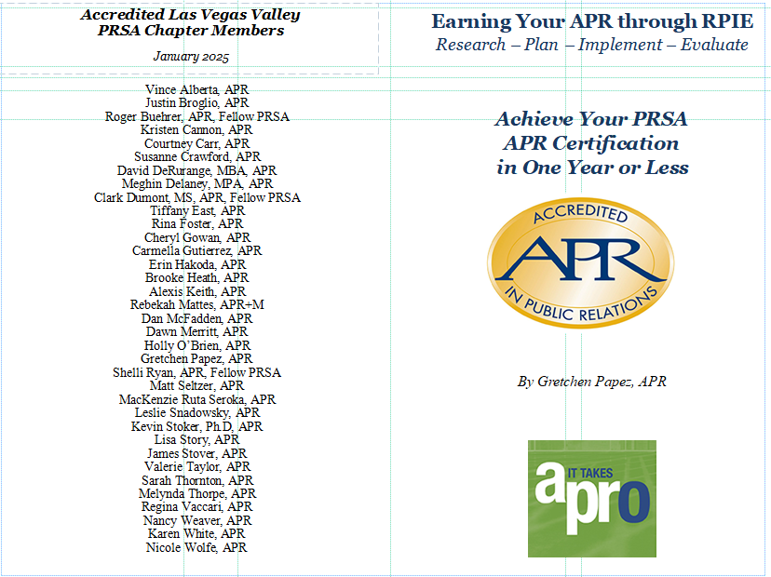

TESTIMONIALS FROM RECENT APRs – SAMPLES
(NOTE: Your chapter’s APR testimonials are helpful to run throughout the year, but particularly when recruiting for your next APR Ready to Roll cohort – be sure to add a head shot for each testimonial)

Melynda Thorpe, APR
Why did you earn your APR? - It was a long-term goal for me, and I had seen others that I admired earn the credential. I realized that if I kept putting it off, I'd never get it done, so a little encouragement from the Las Vegas Chapter was just what I needed.
Benefits of earning your APR? - It has given me increased confidence and opportunities to engage the RPIE planning process. I made new friends in the process. And the recognition of accreditation has opened new opportunities including that of serving as the Utah PRSA chapter president and consulting in my local community.
Pros and cons of the Ready to Roll - This was the friendliest, most supportive study program. Each mentor encouraged me with confidence and I felt professionally and personally lifted through the process. I am proud to be a graduate of the Las Vegas Ready to Roll program!

Matt Seltzer, APR
Why did you earn your APR? I've worked in various roles within the world of Public Relations for nearly two decades, often supporting communications professionals in their roles. However, as I do not practice PR on a day to day basis, it was very important to me that I validated that I knew what I was talking about when I spoke about this world - validated for my clients, and validated for myself as well. The APR allowed me to do exactly that. It gave me the opportunity to put my own knowledge of strategic communications to the test, and delivered for me verification of my skills/capabilities/knowledge, and also provided trust to my clients and partners when discussing their worlds.

Benefits of earning your APR? The two primary benefits I've received from the APR both revolve around reassurance. I learned so much during the APR process, but mostly I received reassurance that the knowledge I've gained throughout my career truly has prepared me to work within the strategic communications ecosphere. This reassurance has helped me professionally as I provide strategic consultation to my clients, and has also provided reassurance to my clients that the information and assistance I provide to them is strategically sound.

Pros and cons of the Ready to Roll -- The pros are the ability to bedrock your knowledge in a time-tested rubric, and backing that knowledge with even more information that's been field tested by myriad practitioners before you. I learned so much about this industry through the program, especially having the opportunity to be trained by so many incredible practitioners from various walks of life.

The cons are the time and commitment, but like anything great in this world, that's a price we have to pay. Preparing for the APR, from start to finish, took months of dedication. And because of that time and effort, I can confidently say I am a better practitioner because of it.

Leslie T. Snadowsky, MS APR
Why did you earn your APR?
The Las Vegas Chapter of the PRSA has embraced my contributions to the local market and encouraged me to seek Accreditation in PR. I come from a print, TV, and multimedia journalism background (Associated Press, Bloomberg, The New York Post, CNN, FOX), so earning my APR was an opportunity to learn more about the “science” of PR. That knowledge has supercharged my PR campaigns, strategies, tactics, and results!
Benefits of earning your APR?
According to the Universal Accreditation Board the APR program “aims to improve the practice of public relations by assessing competence in 60 areas of knowledge, skills, and abilities associated with the profession.” Throughout the process, I enjoyed learning more about the history of PR, communication theory, planning, management science, and ethics.
Pros and cons of the Ready to Roll
I benefited greatly from the PRSA’s Ready to Roll program, which gave me the tools to prepare for my panel presentation and pass my exam. I’m very grateful to the Members of our local PRSA who dedicate their time helping others pursue the only national post-graduate certification program for public relations professionals.

Courtney Carr, APR
Why did you earn your APR? - I have always considered myself to be a lifelong learner. When I heard about the APR Ready to Roll program, it seemed like a pretty logical decision! Plus, earning the APR was a rewarding challenge that shows others I know what I am talking about when making recommendations.
Benefits of earning your APR? - I believe that an accreditation (in a relevant field) can help a person stand out when applying for jobs or graduate degree programs. The APR accreditation also bestows a level of professional credibility that cannot be found elsewhere.
Pros and cons of the Ready to Roll - I really enjoyed the structure that the APR Ready to Roll program provided. It helped pace my studying and also provided a support system with a shared goal.

Brooke Heath, APR
Why did you earn your APR? - I was ready for an opportunity to demonstrate my knowledge of the industry.
Benefits of earning your APR? - too many to list! First and foremost, I have made connections with professionals who are amazing - many have become long-time friends. Secondly, gaining a broader understanding of the RPIE model has completely shifted how I go about projects and campaigns, it's empowered me to ask more questions when stakeholders have requests for one-off tactics to better support them in their overall goals and objectives.
Pros and cons of the Ready to Roll - nothing - it was soooo incredibly helpful to my success!

WEBINAR / ORIENTATION OUTLOOK INVITATION
You’re APR Ready to Roll!
Special VIRTUAL Introduction to PRSA, (INSERT) Chapter’s new APR Program!
(INSERT DATE & TIME) – Webex provided
Pursuing your Accreditation in Public Relations. Of course you’ve thought about it, you’ve chewed on it, but something keeps getting in your way preventing you from preparing for and taking the APR exam. Maybe it’s uncertainty, perhaps the process seems overwhelming, you have so many questions, there’s no time, etc., this is just not the year. Then again, we have answers and a time-tested, proven solution and YOU will be APR Ready to Roll in (INSERT YEAR)!

Make plans to join our special virtual introduction to PRSA, (INSERT) Chapter’s new APR Program. Why is it so different? We have the answers and our spring class is forming now! Just join “You’re APR Ready to Roll,” a brief, 30-minute window of your time coming up (INSERT DATE & TIME) The Webex link is below, just cursor down below my email signature and the best part: you can enjoy it from the comfort of your home or office!
Email me or Accreditation Co-chair (INSERT NAME) if you should have any questions. Block the time on your calendar today! (INSERT YEAR) is YOUR year to be APR Ready to Roll! See you (INSERT DATE & TIME)

Sincerely,

VIRTUAL KICKOFF WEBINAR ANNOUNCEMENT – SAMPLE
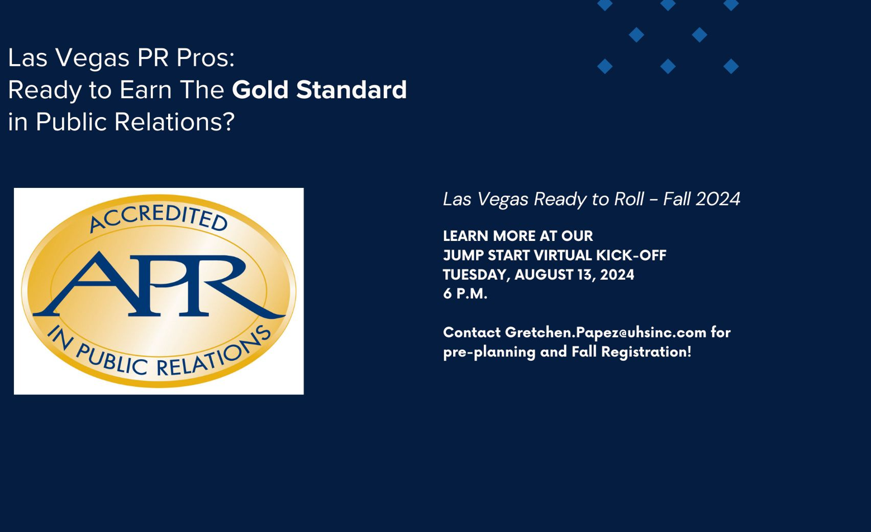

HALLOWEEN THEMED WEBINAR FOR APR READY TO ROLL
(Webinar Info and Newsletter Blurb - See APR HALLOWEEN WORKING PPT file for a supporting graphic you can customize/insert your chapter logo, etc.)
FOR WEBINAR:
HEAD: Webinar: YOU are APR Ready to Roll!
COPY: Are you ready to earn your Accreditation in Public Relations (APR)? With Nashville PRSA's proven APR Ready to Roll program, there are no dark and stormy nights walking the APR road alone. Test anxiety? Fear of the APR unknown? APR Ready to Roll offers you so much chapter support it's SCARY!
Join us for this free webinar coming up Thursday, October 9, noon- 1 p.m. CDT. We'll give you a detailed virtual overview of what to expect, how to prepare, an APR team-driven/coordinated schedule and even a head start if you’d like to pursue achievement of your APR, the gold standard in public relations! (INSERT CHAIR NAME), chair of PRSA (CHAPTER) accreditation committee, will lead this engaging webinar. No jump scares -- we promise!

WEBINAR ANNOUNCEMENT / NEWSLETTER:
HEAD: A Webinar Too Scary to Miss: Learn About APR Ready to Roll Oct. ____
COPY: Is the very idea of pursuing your Accreditation in Public Relations (APR) giving you nightmares?! Have no fear, PRSA (INSERT CHAPTER) 's APR Ready to Roll program is here to help! There are no dark and stormy nights walking the APR alone with our proven APR Ready to Roll program. We'll put your test anxieties and fear of the APR unknown to rest with so much chapter support it's SCARY!
Join us for this free webinar coming up (INSERT DATE AND TIME). We'll give you a detailed virtual overview of what to expect, how to prepare, an APR team-driven/coordinated schedule and even a head start if you’d like to pursue achievement of your APR, the gold standard in public relations! APR CHAIR/CO-CHAIR NAME HERE, co-chair of PRSA ____________s accreditation committee, will lead this engaging webinar. No jump scares -- we promise!

FIRST CONTACT/CANDIDATE EXPRESES INTEREST IN APR: SCHEDULE 1-ON-1 CALL TO UNDERSTAND THEIR NEEDS, GOALS, READINESS FOR PROGRAM
(THEN INVITE THEM TO ORIENTATION) – VERSION 1

HI _________,
It’s wonderful to e-meet you! Congratulations on committing to pursuing achievement of Accreditation in Public Relations (APR), the gold standard in our industry. We’re excited about working with you on your APR journey!
Would you be available for an introductory call or Webex early next week? We’d like to get a better understanding of where you are, learn more about your career path, and how the Nashville chapter’s new APR Ready to Roll program can help you achieve your goal (we’ll have more details and timeline on the call). Let me know your availability and we’ll go from there.

Thanks and have a great night!

Dan

LINKED IN ARTICLES – SCREENSHOT
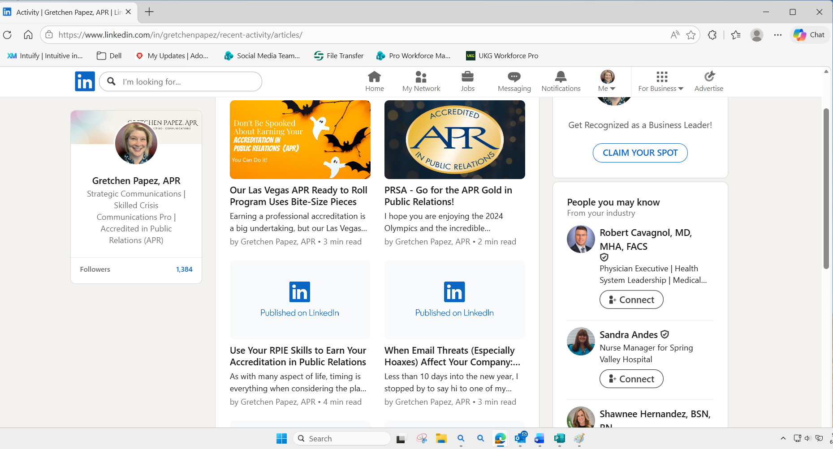

CHAPTER ACCREDITATION WEB PAGE – SAMPLE
(NOTE: Check out the great content, testimonials and more from LVV Chapter – great model to follow)
PRSA Las Vegas Valley Chapter - APR Accreditation
SCREEN SHOTS:
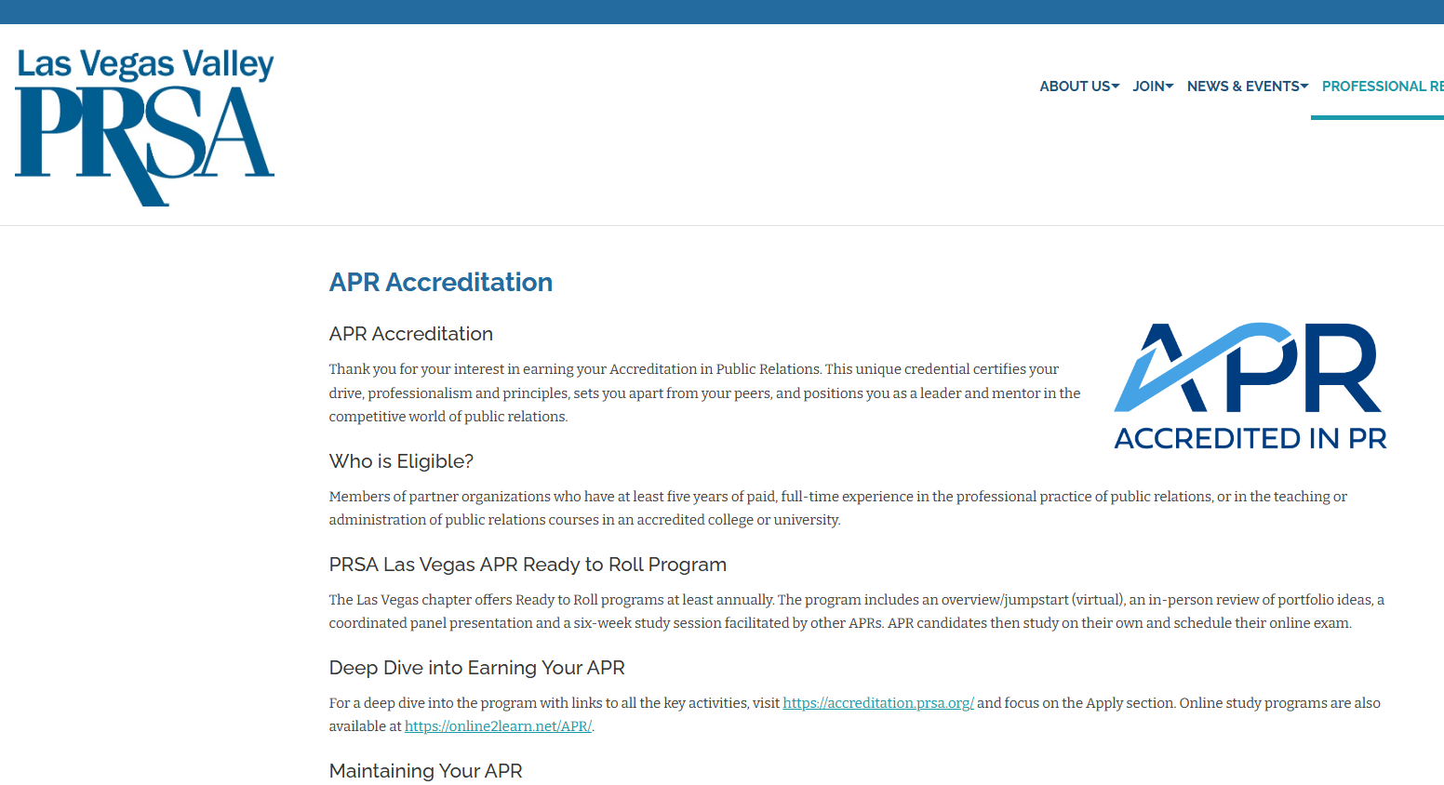

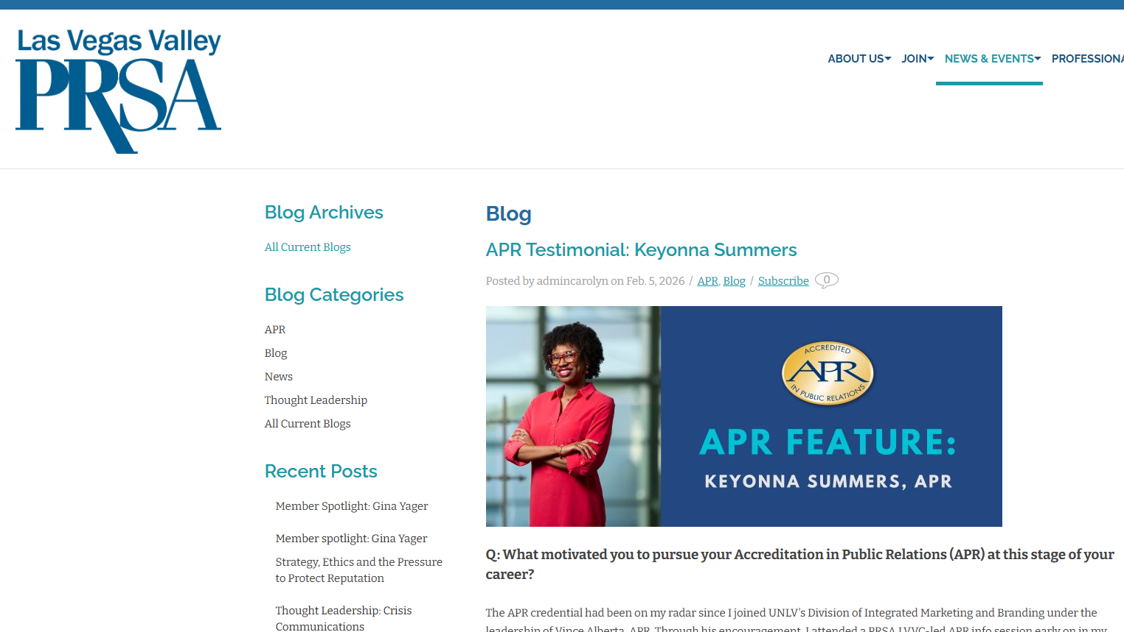

APR SKILLS FOR SUCCESS CANDIDATE SURVEY / RESULTS
(NOTE: Adapt this survey from PRSA Nashville to gauge APR candidate’s interest and APR readiness)

https://docs.google.com/forms/d/e/1FAIpQLSdm9X3r1JyCnjGZcbTzHRFQ1YGslYtuZ6rNd79bcIEPNnyRhQ/viewanalytics
SCREEN SHOTS:
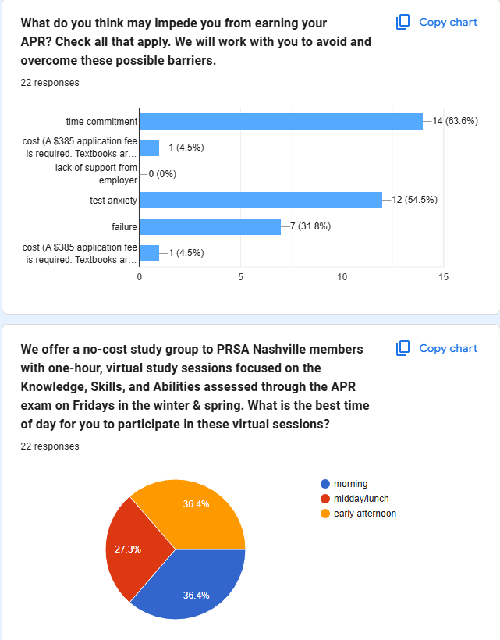

FIRST CONTACT/CANDIDATE EXPRESES INTEREST IN APR: SCHEDULE 1-ON-1 CALL TO UNDERSTAND THEIR NEEDS, GOALS, READINESS FOR PROGRAM
(THEN INVITE THEM TO ORIENTATION) – VERSION 2

Hi _______________,

Congratulations on taking the next step in your professional development: pursuing achievement of Accreditation in Public Relations (APR), the gold standard in our industry. As co-chair with (INSERT NAME), we are excited to support and guide you along your journey to the APR through PRSA (CHAPTER)’s APR Ready to Roll program, an aggressive, structured, and time-tested, proven strategy designed to help you reach your goal.

Next steps:

- (INSERT DATE & TIME): Be sure to join our 30-minute Webex introduction to the APR Ready to Roll program and process. We’ll provide you all the details about the program, study schedule sessions, resources, etc. You’ll be joined by joined by fellow peers who have committed to the process and others who are seeking more information. I’ll forward you the invitation under separate cover.
- Introductory call: I’d very much like to spend 15 minutes with you in advance of (INSERT DAY’S) Webex to learn more about you, your experience, and how we can best support you. Let me know when you have windows of availability in your day or early evening if that works better for you between now and (INSERT DAY).
- Interested in having an APR mentor? Please reach out to (INSERT NAME/WHOMEVER WILL COORDINATE CHAPTER MENTORS), who will match you with a mentor.

Congratulations once again and we look forward to working with you in the weeks and months ahead.

Sincerely,

CANDIDATE’S APPLICATION HAS BEEN APPROVED, FOLLOW UP EMAIL SCHEDULE 1-ON-1 CALL TO UNDERSTAND THEIR NEEDS, GOALS, READINESS FOR PROGRAM
– VERSION 3

Hi (INSERT NAME),

I and my PRSA Nashville Accreditation Co-chair, (INSERT NAME), congratulate you on taking the first, exciting step to achieving your Accreditation in Public Relations (APR) certification!! It’s wonderful news that your application was approved by the Universal Accreditation Board (UAB) and we’re here to help you achieve your goal!

Our APR Ready to Roll Class of (INSERT YEAR) work sessions are about to begin. I’d like to schedule an introductory call to learn more about your experience and goals, plus share the program with you, what to expect, how it works, time commitments, etc. Would you have time on your calendar (INSERT DATE) for a 30-minute Webex call?

Also, watch for an email with key dates, information and resources from later this week. Super helpful information will be coming your way!

I look forward to meeting you and congrats again – you ARE APR Ready to Roll!

Sincerely,

Dan

CANDIDATE HAS ATTENDED ORIENTATION/REQUESTS ONLINE APPLICATION EMAIL

Dear _______,
Thanks for joining us today for the APR Ready to Roll overview!

Here’s the link to submit your online application: (NOTE – ENSURE THIS LINK IS STILL ACTIVE ON NATIONAL SITE)

Main page: https://www.prsa.org/professional-development/accreditation-in-public-relations-(apr)
Look for the APPLY ONLINE button lower right (you’ll have to log in with your PRSA username and password).
You’ll see there are six sections/tabs to complete, followed by application fee.

I’ll follow up with the PP deck and schedule later today. Also, I advised (INSERT NAME) (cc’d here) that you would like a mentor.

Please let us know if you have any questions. We look forward to helping you achieve your APR!

Sincerely,

CANDIDATE QUESTIONS RE: APR and APR+M - Sample EMAIL
Hi _______,

According to PRSA, the difference between the APR and APR+M lies in the panel presentation process. APR+M candidates complete a different panel presentation questionnaire from APR candidates. BUT all candidates (APR and APR+M) take the same exam so our APR Ready to Roll Study Sessions are made for all candidates! PRSA National hosts APR+M panel presentations periodically and dates have not been determined for next year but usually around the same time. Candidates can pursue the APR+M all at once and do not need to accomplish APR first.(https://accreditation.prsa.org/MyAPR/Content/Apply/APR-M/APR-M.aspx)

Please see the (INSERT YEAR) dates just for reference in my earlier email.
Hope this helps and we'd be honored to support you on your APR+M journey through PRSA (INSERT CHAPTER'S) APR Ready to Roll program.

ACCREDITED MEMBERS GROUP EMAIL – ALL HAVE AGREED TO LEAD AN APR STUDY SESSION – DETAILS PROVIDED FOR THEIR REVIEW
(NOTE: Remember to provide your APR leaders the PP deck to lead their study session – this is included in the DOWNLOADS package in PDFs for quick and easy reference OR download from the PRSA National site)

Good evening PRSA (INSERT CHAPTER) APR leaders!

Thank you for volunteering to lead one of our PRSA (INSERT CHAPTER) APR Ready to Roll study sessions! As PRSA (CHAPTER) Accreditation Co-chairs, (INSERT NAME) and I greatly appreciate you volunteering to share your real world expertise and insights as accredited public relations practitioners. Your gift of time will be invaluable to our APR candidates on their professional journey to achieving the APR, the gold standard credential in our industry.

We recently polled our potential candidates regarding preferred days and times for their APR study sessions; they advised that mornings, Thursdays first and Fridays as one option, are their best times of availability. That being said, attached for your immediate reference is a draft APR program study schedule with dates and times starting in May (all are virtual study sessions, unless you’d prefer in person). Here’s our time-sensitive ask of you:

- Review your study session date and time – can you make the session as written?
  - If not, please provide a proposed date and time that works for you.
- Prefer to conduct your study session in person? Let us know if you can host at your business and, if not, we’ll make other arrangements.
Please send me your responses by (INSERT DATE) and let me know if you have any questions. Once the schedule is firmed up, we’ll share with our APR candidates, send Outlook invitations to block dates on calendars, and follow up with each of you individually with more details.

Thank you in advance for your APR leadership and commitment to the professional growth and development of our chapter members. With your help, PRSA (INSERT CHAPTER) APR Class of (INSERT YEAR) candidates will be APR Ready to Roll!

Sincerely,

ACCREDITED MEMBER AGREES TO LEAD APR STUDY SESSION EMAIL
(SAMPLE – THIS LEADER REQUESTED ONE SESSION ALREADY FILLED)

Hi ___________,

We so appreciate your participation and offering to lead one of our upcoming APR study sessions. We’re filling in the sessions and have a quick question: you requested leading RPIE – while we have those two sessions filled, we would be honored if you would consider leading the Managing Relationships session. As planned, it will be held the week of (INSERT DATE), but details are still being ironed out. If you agree, do you have a preference: in person, virtual or hybrid?
___________, we are grateful for your consideration and PRSA leadership – with your help, we know our candidates are well on the road to achieving their accreditation. May we pencil you in for Managing Relationships?
Thank you once again!
Sincerely,

ACCREDITED LEADER SET TO LEAD STUDY SESSION EMAIL
(NOTE: Remember to send the study session PP deck(s) to the APR leaders at least two weeks in advance of their presentation. These decks, PDFs, are available in the DOWNLOAD folder for quick and easy reference or they may be downloaded from PRSA National’s site.)
(NOTE 2: Great to thank/recognize publicly the APRs who contribute to any APR Ready to Roll session, serve on panel, etc., at your Board meetings)

Hi _________,
Attached for your immediate reference are the UAB-provided decks for (INSERT TOPIC/STUDY SESSION).
Thank you once again for leading (INSERT DATE’S) session and your support of PRSA (INSERT CHAPTER’S) APR Ready to roll program!
Please let me know if you have any questions.
Sincerely,

PANEL QUESTIONNAIRE WORK SESSION EMAIL INVITATION: APR CANDIDATES (NOTE: Be sure to have a couple of completed SAMPLE QUESTIONNAIRES provided by APRs to share at your work session – IMPORTANT!)

PRSA Nashville APR Ready to Roll
APR Panel Questionnaire Work Session
LOCATION: (INSERT)

Mark your calendars for this in-person, 60-minute questionnaire work session. I’ll provide a few couple of sample questionnaires for reference and be there to answer your questions and support you in preparation for submission by (INSERT DATE).

Let me know if you have any questions. I’ll follow up with directions shortly.

You ARE APR Ready to Roll!!

Sincerely,

PANEL QUESTIONNAIRE IS DUE / REMINDER EMAIL: APR CANDIDATES:
Dear (INSERT NAMES),
Friendly reminder! Your panel presentation questionnaires are due (INSERT DATE). Please reply to this email with a PDF, Google Doc or Word Document.
You’ve got this because YOU are APR Ready to Roll!

Sincerely,

CANDIDATE COMPLETES/RESPONDS-SUBMITS PANEL QUESTIONNAIRE – CONGRATULATORY EMAIL
Dear _______,
Well done and congratulations on completing your panel questionnaire! You’re on your way and APR Ready to Roll!!
Sincerely,

EMAIL TO APR CANDIDATES SCHEDULED TO GIVE PANEL PRESENTATIONS SOON
PRSA _____ Panel Presentation Resources and Reminders
For those giving their Panel Presentations in (INSERT MONTH), please reply to me with a PDF of your completed questionnaire by (INSERT DATE)

Resources to prepare for your Panel Presentation:
- Practice answering the questions on page 12 of the APR Study Guide.
- Listen to PRSA Pikes Peaks' podcasts "How to Start and Finish Your APR Questionnaire” and "How to Prepare for the APR Panel Presentation."
- Watch APR Panel Presentation: Secrets to Success
On the day of your Panel Presentation, bring:
- 3 printed questionnaires (a copy for each panelist is ideal)
- 3 portfolios (a copy for each panelist is ideal)
- your tablet/laptop with Zoom installed to project your visuals/slides onto the TV in the conference room (NOTE: insert whatever specific tech instructions needed for your location)
If you have any hiccups the day before or day of your Panel Presentation, please text/call:
- Insert dates / locations of your panel presentations and the contact name of your APR chair here for APR candidates' quick reference

You ARE APR Ready to Roll!
Sincerely,

REMINDER EMAIL (DETAILED) TO CANDIDATES BEFORE PANEL PRESENTATION

Dear (INSERT NAMES)

Good afternoon! We/I have coordinated your APR Panel Presentations coming up this (INSERT DATE). By taking this important milestone step you are nearing the light at the end of the tunnel on your journey to achieving APR. Detailed directions and parking information are pasted at the bottom of this email and attached for quick reference – there are some timing instructions for the panel, but follow those outlined below:
- FIRST CANDIDATE NAME: Please arrive at LOCATION by ____. The panel will arrive by (15 minutes later). This will give you time to set up your laptop/test the equipment and have your 3-ring binders in advance for their arrival.
- CANDIDATE 2: Same as above – please arrive by (2 HOURS LATER). As soon as the panel completes their review, they will have a break to give you time for setup (plus, if they finish early, you’ll be ready to go).

Panel Presentation Overview

To recap, the Panel Presentation plays an important role in the Accreditation process. It evaluates, through a questionnaire and live presentation your knowledge, skills, and abilities that cannot effectively be judged in the computer-based examination.
A panel for each candidate's Panel Presentation is comprised of three current APRs, one of whom serves as chair. They are charged with offering both an accurate assessment of the candidate and to serve as a resource for the candidate, as they prepare for the computer-based Examination.
Who Makes a Good Panelist for the Panel Presentation?

• A demonstrated interest in the Accreditation process

• A reputation for providing fair, unbiased, objective assessments of problems and situations

• Proven skills in mentoring, teaching and coaching

• In‐depth knowledge of the public relations profession

• Familiarity with at least one of the study books from the short bookshelf

• Good decision‐making skills as demonstrated in Chapter business or through work experience

• A dedication to task that allows for thoroughness, timeliness and follow‐up

• A willingness to help others

• Time (about five hours) to commit to helping others

Resources and Tips
Also attached are the APR KSAs tested for your immediate reference. A few last-minute tips:
- Remember, get plenty of rest the night before your exam (AND be prepared to give yourself time to rest AFTER your presentation)!
- Bring your (4) 3-ring binders (one for each panelist, one for yourself) and your PP presentation pre-loaded on your laptop.
- Dress for a job interview, keep the conversation going throughout your presentation and stay sharp, always professional. Bring your A game!
- You KNOW your PR plan ,now tell your STORY, connecting the dots / weaving the narrative throughout your presentation. You KNOW the 4-step process, SHARE your work, lessons learned, how the APR Ready to Roll program and process are helping you grow as a PR practitioner, etc.
- It’s ok to share your failures and provide your own self-assessment, opportunities you’ve identified for continued growth and development.

I look forward to seeing you (INSERT TIMES). If you have any questions, please call / text my cell _____________ AND reply to this email with your cell number.
You are APR Ready to Roll!!!
Sincerely,

CONSIDER REHEARSING YOUR PANEL PRESENTATION WITH MENTOR – EMAIL TO APR CANDIDATES

Dear APR candidates,

If you haven't already, please consider rehearsing your Panel Presentation with your mentor. As an Accredited member who has previously served as a panelist, your mentor can give a constructive critique and offer questions that the panel is likely to ask.

Finally, if you are presenting (INSERT DATE) at (INSERT LOCATION), remember to bring your tablet/laptop to project your visuals/slides onto the TV in the conference room. Be sure to let me know if you are bringing a PC or Mac (NOTE TO CHAIRS: Insert any tech info, advise about adaptors needed, if any, etc., to test the equipment).
Please reach out to me at (INSERT PHONE #) with any questions. You ARE APR Ready to Roll!

Sincerely,

ANOTHER SAMPLE EMAIL TO CANDIDATES PREPARING TO GIVE THEIR PANEL PRESENTATION WITH TIPS

Dear (INSERT NAMES)

We would like to congratulate you once again on your commitment and journey to achieve your Accreditation in Public Relations (APR). We’re excited for you that your Panel Presentation is just around the corner, this (INSERT DATE) at (INSERT LOCATION) (see photo instructions attached).

As a reminder, your panelists will be (INSERT YOUR PANELISTS’ NAMES – THESE ARE SAMPLE TIMES BELOW FOR REFERENCE):
- 9:00 a.m. (INSERT NAME) (arrive at 8:45 a.m.)
- 10:30 a.m. (INSERT NAME) (arrive at 10:15 a.m.)
Next, final steps in prep for your panel presentation:

- Arrive at least 15 minutes early (as outlined above) so you will have time to catch your breath and gather your thoughts.
- Prepare and present as if you are going to a job interview (your panelists may be in Saturday casual, but you’re “going for the job”!).
- IMPORTANT: Email (INSERT CHAIR’S NAME) your PP presentation, if you choose to use one by (INSERT DATE/TWO DAYS BEFORE PANEL). I will pre-load it onto my laptop, but prefer you not bring a thumb drive. If you choose to bring your own laptop, make sure you have the standard HDMI cable connectivity (we have a one-size HDMI cable in the conference room).
- Reference the Panel Presentation candidate instructions attached.
- Bring three / technically four copies of your portfolio (a 3-ring binder, tabbed – just remember the sample we shared) one for you and one for each panelist. It’s important that panelists may scan through the portfolio with you without having to pass one around.
- Prepare for your panelists to engage with you; remember, this isn’t a 45-minute presentation followed by Q&A, they will be actively engaging you and asking questions along the way. Don’t let that trip you up, keep it conversational, show enthusiasm and that you know your KSAs.
- The panelists are PULLING FOR YOU!! They’re in your corner, they want to see you SUCCEED!!
- It’s OK if you came up short somewhere in your plan. Providing them your own self-analysis/opportunities for continued growth through the APR process is good thing, they’ll know you’re heading in the right direction.
- Upon completion of the panel presentation, the panelists will convene and determine whether candidates advance or choose not to advance at this time. PRSA will communicate with you within a week’s time.

Please reach out to either of us if you should have any questions before (INSERT DAY’S) panel. My cell number is (INSERT).

You’re prepared, you have the knowledge, skills and abilities, plus you have an excellent portfolio/case study to share. You’ve got this. You are… APR Ready to Roll!!!

Sincerely,

REMINDER EMAIL TO CANDIDATES BEFORE PANEL PRESENTATION
Hi, __________,

I look forward to seeing you tomorrow (insert time) ________________ for your Panel Presentation at ______________. Parking instructions are attached/pasted below for your immediate reference. Please arrive 15 minutes early to get set up and settled in preparation for your panel.

Remember, you ARE APR Ready to Roll!! You can do this!!

APR PANEL PRESENTATION TOMORROW - SAMPLE TEXT TO CANDIDATES
Hi _________,
Happy Day Before APR Panel Presentation Day! Here's a quick note to congratulate you on your excellent planning and preparation for your APR Panel Presentation tomorrow. Remember to prepare for it like a job interview, remain confident, engage your panel in conversation, listen and take to heart their important feedback. They (and we) are pulling for you! You're APR Ready to Roll!!

APR PANELISTS EMAIL WITH DETAILS/PREP
(NOTE: Be sure to attach each candidate’s Panel Presentation Questionnaire, Panel Presentation Guide and Materials, and APR KSAs) – These 2 are in the download folder for quick and easy reference or they may be downloaded from PRSA National site.
Your Upcoming APR Panel Presentation Questionnaires and Resources
(INSERT DATE / TIME) -- PRSA (CHAPTER) Panel #1
LOCATION (map and instructions attached)

Dear Accredited colleagues,

Thank you for agreeing to serve on Panel #1 for APR candidates to be held (INSERT DATE). We are honored that you’ve volunteered your time to serve as panelists. Please arrive at (INSERT LOCATION) by (15 MINUTES AFTER CANDIDATE HAS COMPLETED SETUP) to get settled in and ready for the (INSERT #) candidates.
We have (INSERT #) outstanding APR candidates ready for their panel presentations. The schedule is below along with each candidate’s Panel Presentation Questionnaire, the Panel Presentation Guide and Materials and APR KSAs tested attached (I’ll provide hard copies of the day of the panel presentations).
Please reply with any questions and thank you once again for volunteering your time to support our APR Ready to Roll candidates! (NOTE TO APR CHAIRS: These are sample times)
- 9:15 a.m. Panelists Arrive
- 9:30 a.m. Candidate #1 Name
- 10:45 a.m. Candidate #2 Name
- 12 p.m. Lunch (APR Chair will order)
- 12:30 p.m. Candidate #3 Name
- 2 p.m. Panelists Depart
Panel Presentation Overview
The Panel Presentation plays an important role in the Accreditation process. It evaluates, through a questionnaire and live presentation, knowledge, skills, and abilities that cannot effectively be judged in the computer-based examination.
A panel for a candidate's Panel Presentation is comprised of three current APRs, one of whom serves as chair. They are charged with offering both an accurate assessment of the candidate and to serve as a resource for the candidate, as they prepare for the computer-based Examination.
Who Makes a Good Panelist for the Panel Presentation?
- A demonstrated interest in the Accreditation process
- A reputation for providing fair, unbiased, objective assessments of problems and situations
- Proven skills in mentoring, teaching and coaching
- In‐depth knowledge of the public relations profession
- Familiarity with at least one of the study books from the short bookshelf
- Good decision‐making skills as demonstrated in Chapter business or through work experience
- A dedication to task that allows for thoroughness, timeliness and follow‐up
- A willingness to help others
- Time (about five hours) to commit to helping others
Sincerely,

SAMPLE THANK YOU CERTIFICATE – PANEL PRESENTATION PANELISTS
(NOTE: Present a thank you certificate to your panelists immediately following the panel presentations and voting, take a photo for chapter newsletter and social media)

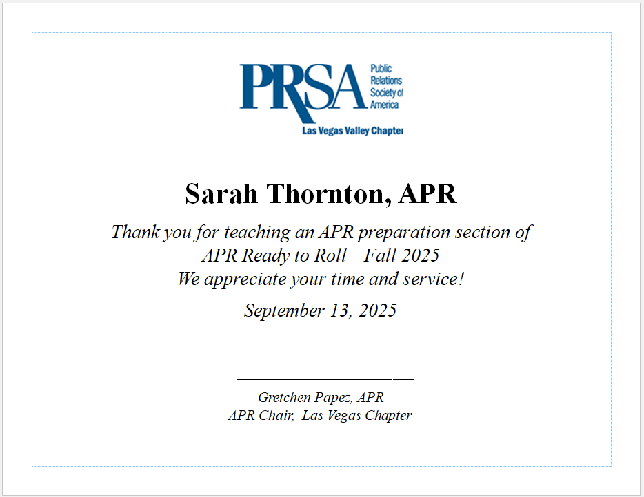

SAMPLE CONGRATULATIONS/APR ACHIEVEMENT TEXTS:

WOW!! Congratulations, _____________!!! I knew you were going to bring it home!! You have achieved APR, the gold standard in our industry. Well done and celebrate, my friend!! Hat’s off to you — we can’t wait to pin you at ______________!!! I know you will rest well tonight. Congrats again!!!

Congratulations, ________, and way to go!! You rocked it, how does it feel being an APR? Know that YOUR success will encourage others and we cannot wait to celebrate you at the APR Pinning Ceremony coming up ______________.
I hope you'll share your testimonial with others... please consider writing a short article for the newsletter or social media about your journey through the APR Ready to Roll program. Members will love to read it and engage with you!

CONGRATULATORY EMAIL TO NEW APR, SHARING WITH CANDIDATES SCHEDULED TO TAKE THE EXAM (MOTIVATION – Remind your candidates to alert you about their scheduled exam date so you may send them an encouraging text the day before)

Dear (INSERT NAMES),
Congratulations to (INSERT NAME), APR the newest Accredited member of PRSA (INSERT CHAPTER). We look forward to pinning (INSERT NAME) during the (CHAPTER EVENT) on (INSERT DATE).

Happy studying to each of you. Please let me know when you have scheduled your exam so that we can share an encouraging word the day before. And do reach out with any questions.

You ARE APR Ready to Roll!
Sincerely,

EMAIL TO COMMS COMMITTEE – REQUEST TO SHARE NEWEST APR’S TESTIMONIAL IN NEWSLETTER/SOCIAL MEDIA - SAMPLE

Hi (INSERT NAME),

Drafted below is a short blurb and testimonial announcing (INSERT NAME) as our chapter’s latest APR! Would you consider including in the next newsletter and/or social media? I’ve attached their head shot as well for your immediate reference.
Thanks for your consideration!

Sincerely,

SAMPLE
Accreditation Corner: Jared Porter earns APR!
Congratulations to Jared Porter, APR (Accredited in Public Relations), PRSA Nashville chapter’s first newly-accredited member in 2024 and first graduate of our APR Ready to Roll program!

Porter shares his APR journey, “The APR Ready to Roll program is invaluable. It not only guided me through the accreditation process; it provided the framework I needed to succeed. Having support from respected mentors, in-depth study sessions, and a resource lending library gave me every advantage. If you're considering the APR, this program will help you achieve your goal. I can't recommend it highly enough.”

PRSA Nashville’s accreditation committee co-chairs, Dan McFadden, APR and Juanita Traughber, APR, have led APR candidates through this accelerated, structured program providing chapter support and resources to complete the APR process in five months or less. APR Ready to Roll provides an organized professional development environment offering structured schedule, weekly study sessions led by experienced chapter APRs and APR mentors.

Porter and other APR candidates will be pinned at PRSA Nashville’s Parthenon Awards on August 22, 2024 at the Fisher Center for the Performing Arts at Belmont University.

Inspired by Jared’s achievement and interesting in pursuing your APR? Contact Dan or Juanita to learn more about the next cohort coming soon!

